NAME:Rishik JK
REG.NO :192511052

CSA1702-ARTIFICIAL INTELLIGENCE
LAB EXPERIMENT

18. Prolog Program for a Database with Name and DOB

1. Aim
To write a Prolog program to create a database containing names and dates of birth and retrieve the date of birth of a person.

2. Algorithm
- Start the program.
- Create a database using the person predicate.
- Store the name and date of birth of different persons.
- Define a query to search for a person's date of birth.
- Give the person's name as input.
- Display the corresponding date of birth.
- Stop the program.

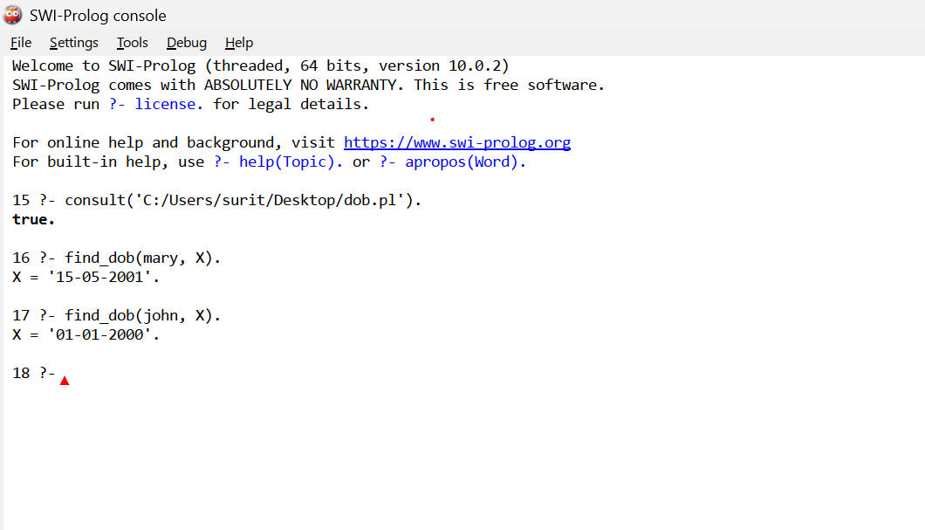

Result
Thus, the Prolog program to create a database containing names and dates of birth was successfully implemented and executed. The date of birth of the given person was retrieved successfully.

